VPC Task - 2

1. Create one VPC, with 1 public subnet and 1 private subnet
Go to VPC and create one VPC
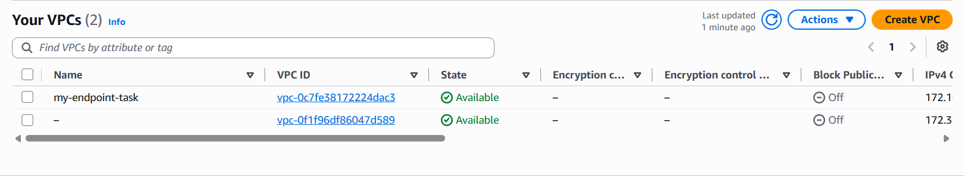
Then create 2 subnets, one public and one private subnet
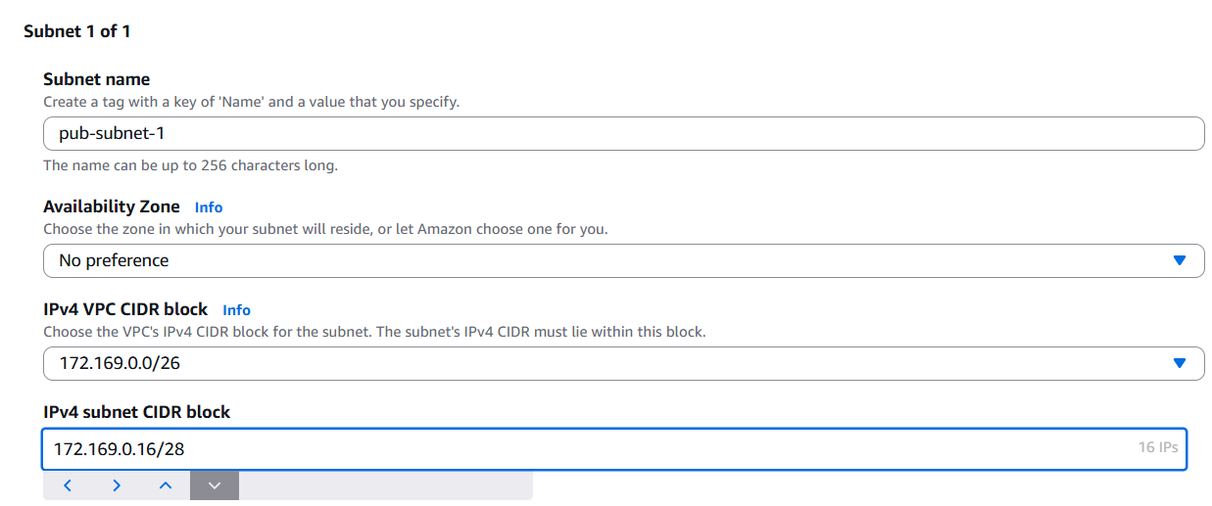
Here you can see there is one public and private subnet has been created
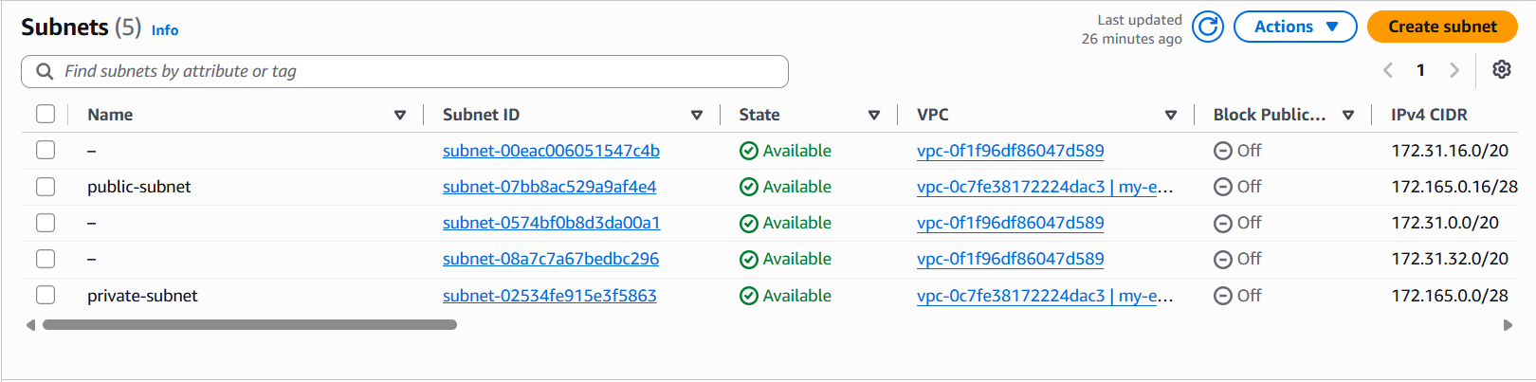
And we need to create 2 route tables for public and private
Associate the subnets with the route table accordingly
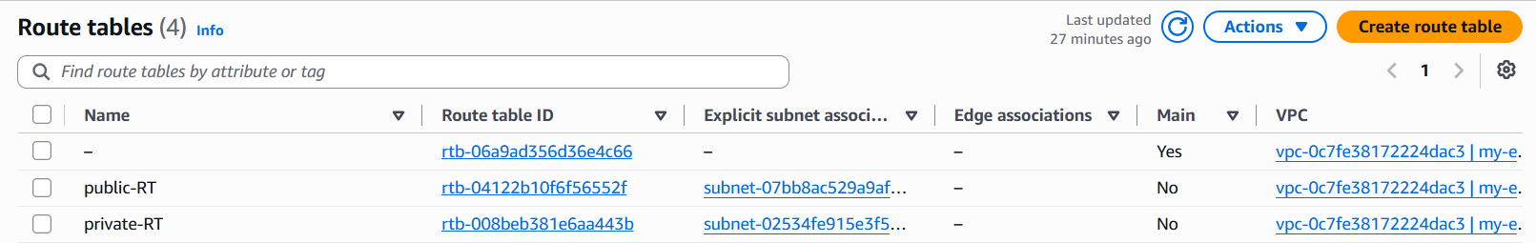
Then create a Internet gateway for configuring the public and private subnets
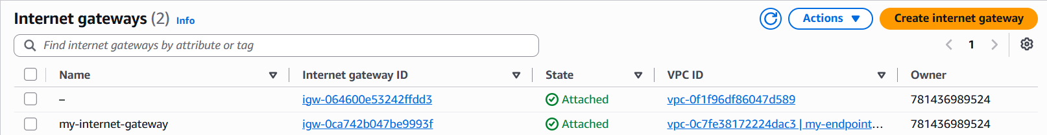
And attach the internet gateway to your VPC
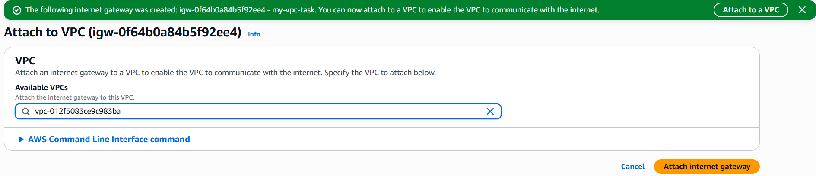
Configure this Internet gateway in the route table of public subnet, it is created
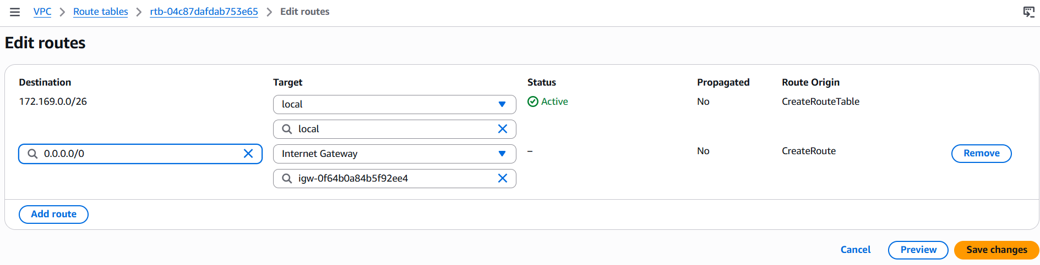

2. Enable VPC peering for cross-region
For cross region VPC peering, first we need two VPC’s from different regions to make it
Note: It should have different CIDR’s
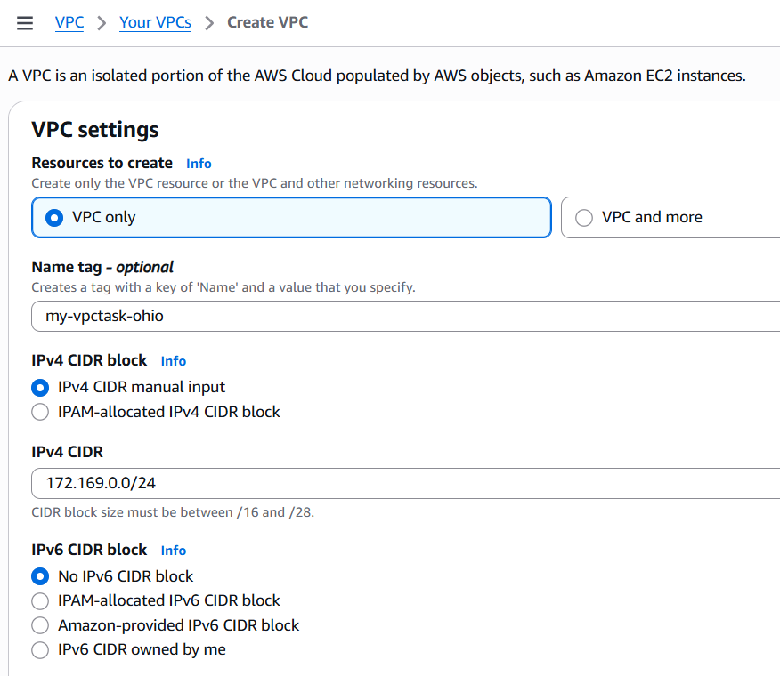
Then, Go to VPC console and Peering connections
Click create peering connection
There, select my account and different region

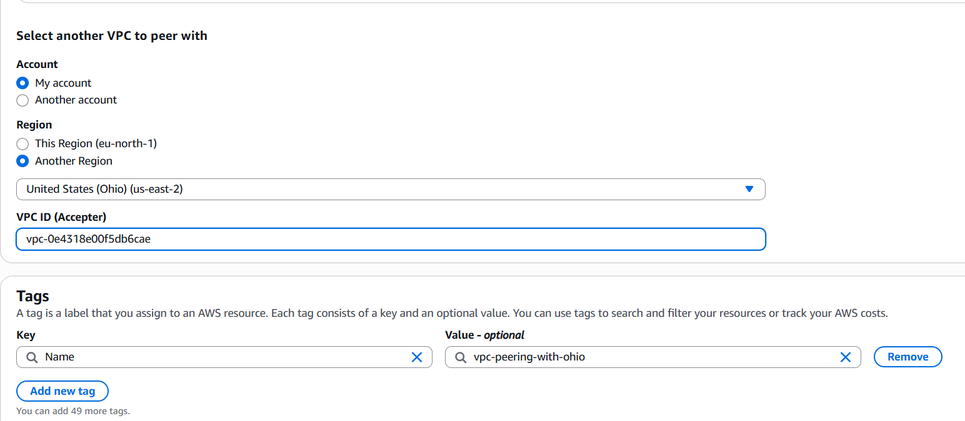
Then you can sent the request the connection to that acceptor region
Switch to that region and accept the peering request
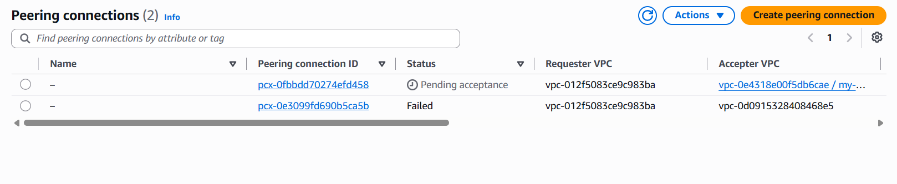
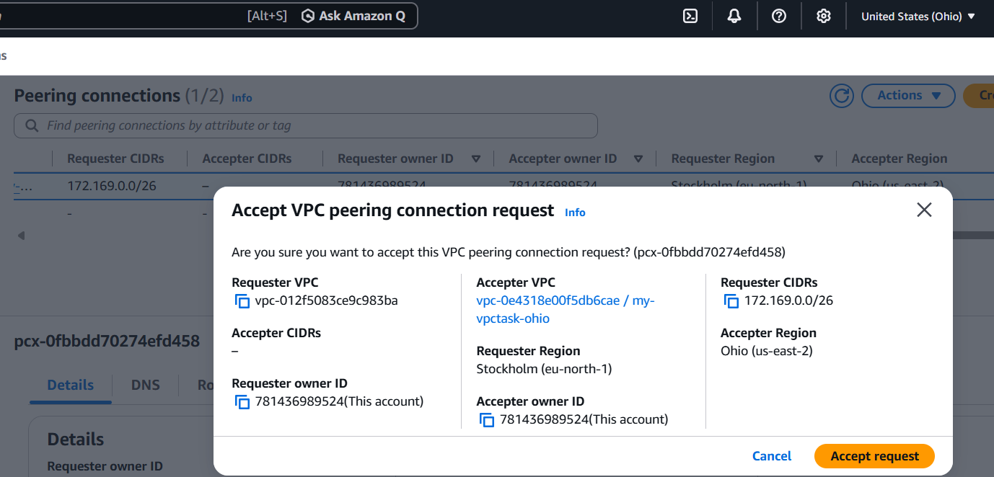
Once it is accepted, the connection has been established
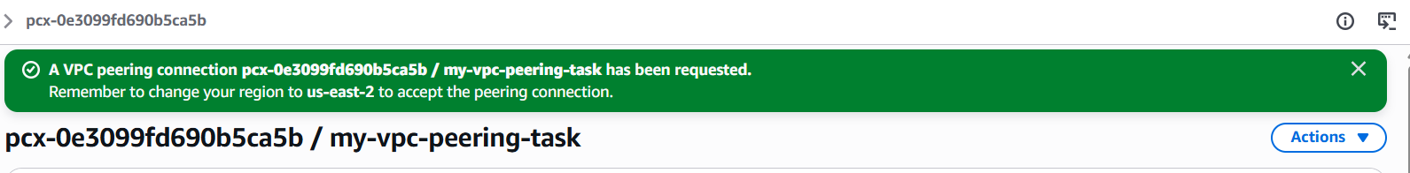
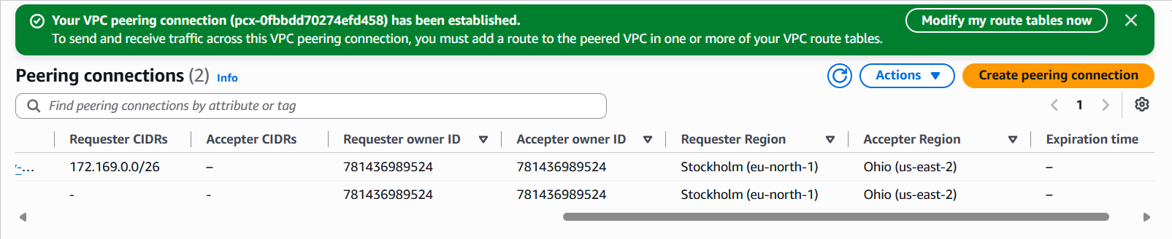
As, you can see above, it is in provisioning

3. Enable VPC peering for cross-account (you can collaborate with your friend to do this task)
Go to Peering Connections → Create Peering Connection.
Select Requester VPC (your VPC).
Select Another AWS Account.
Enter your friend's AWS Account ID.
Select your friend's VPC ID and Region.
Click Create Peering Connection.
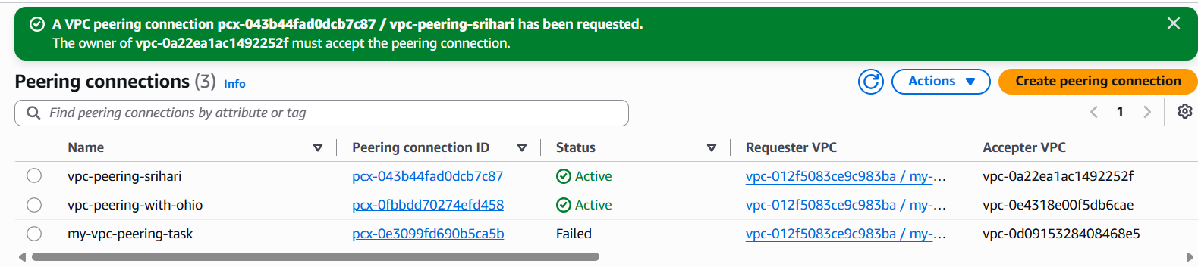
Peering connection has been requested
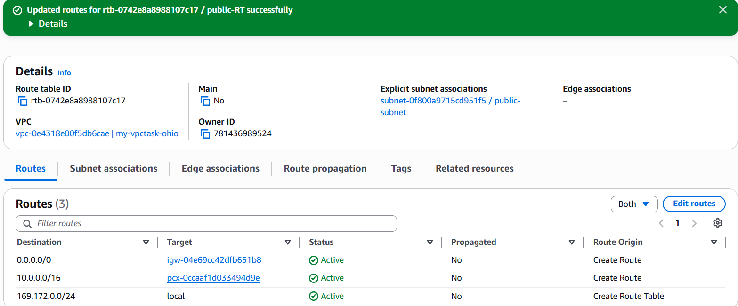
As you can see the requester accepted the peering request below
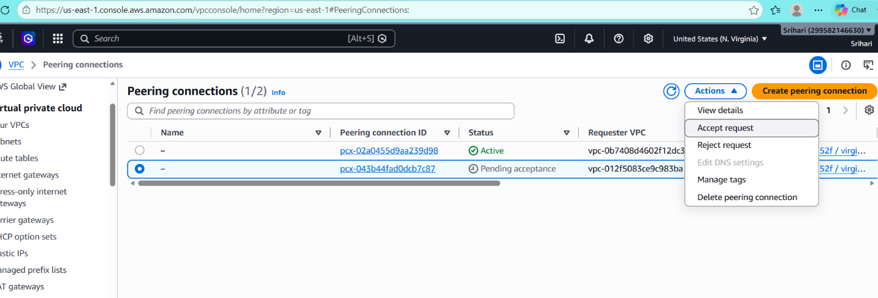
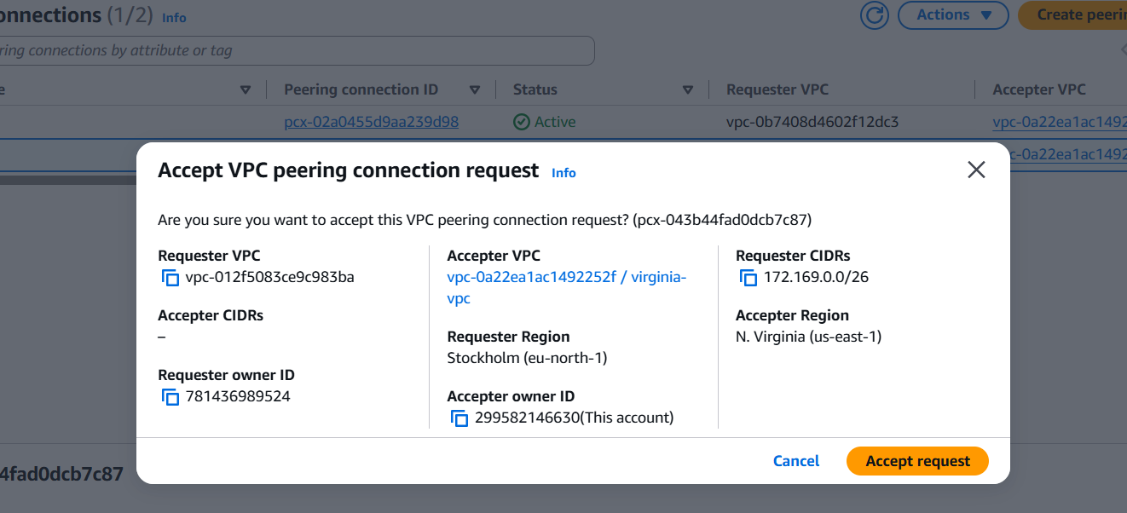
And your friend needs to accept the request and it changes to provisioning
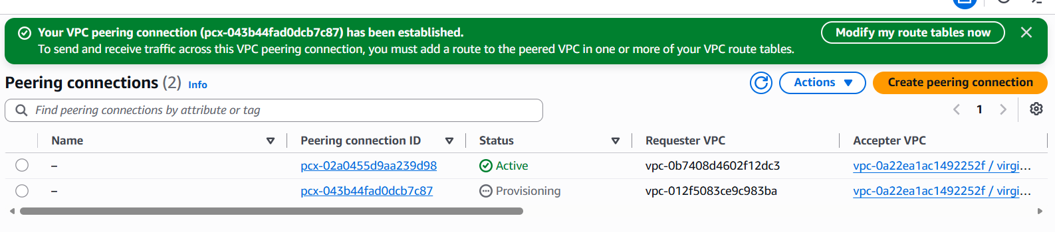
Update Security Groups
Add inbound rules to allow required traffic
Launch EC2 instances in both VPCs.
Ping the private IP or SSH between the instances to verify connectivity.

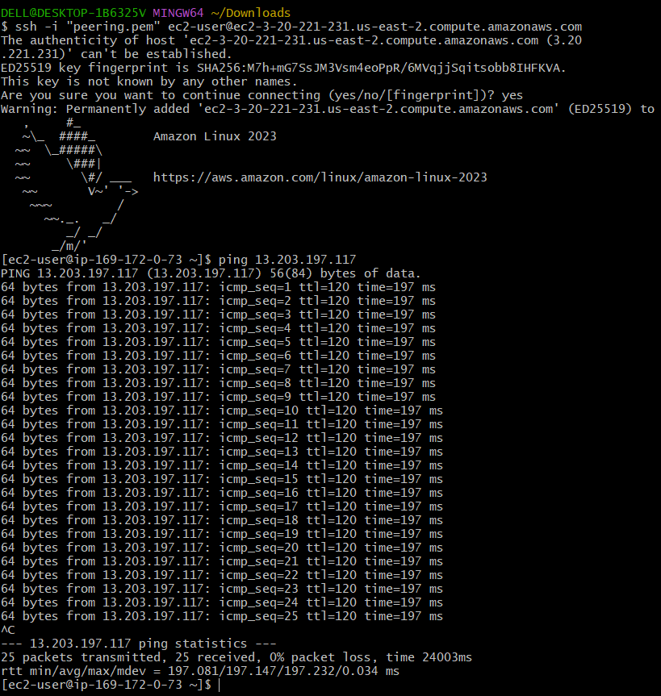

4. Set up a VPC Transit Gateway
Create 3 new VPC’s
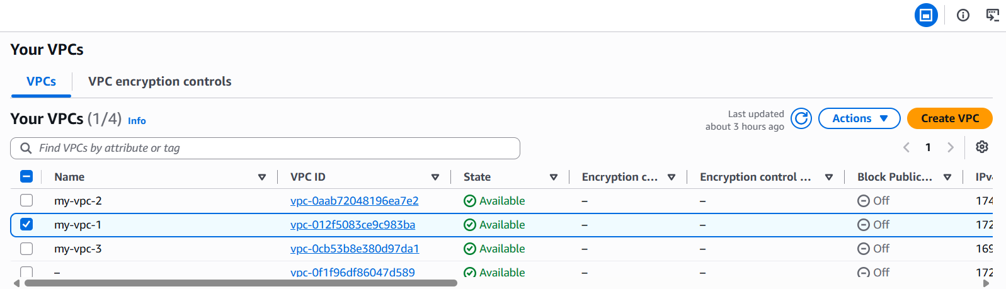
Create 3 new public subnets and configure it in route table
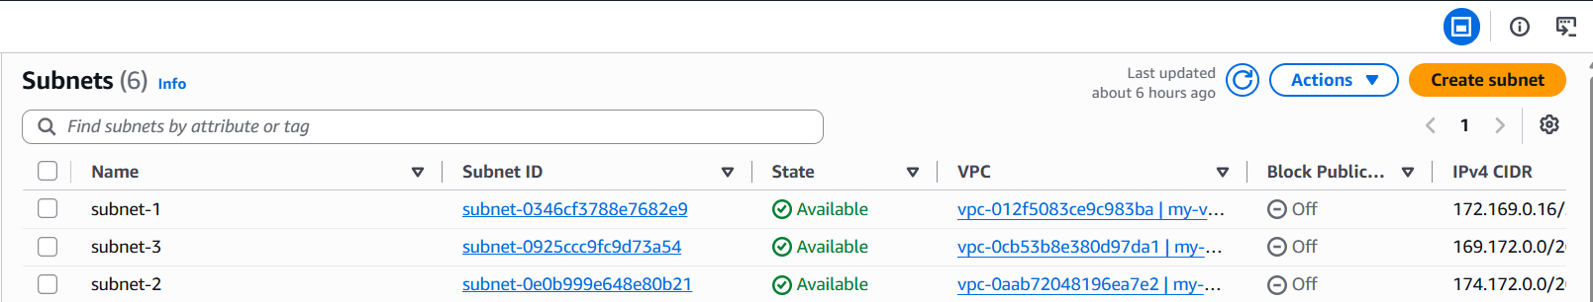
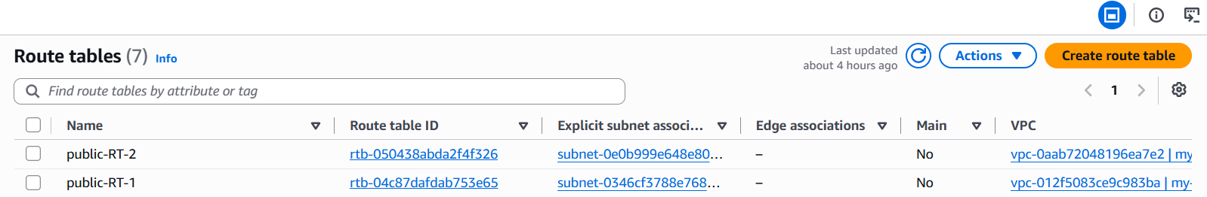
Create a transit gateway
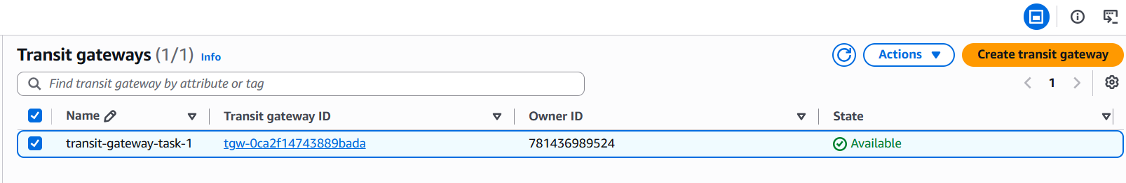
And create attachments according to the number of VPC’s
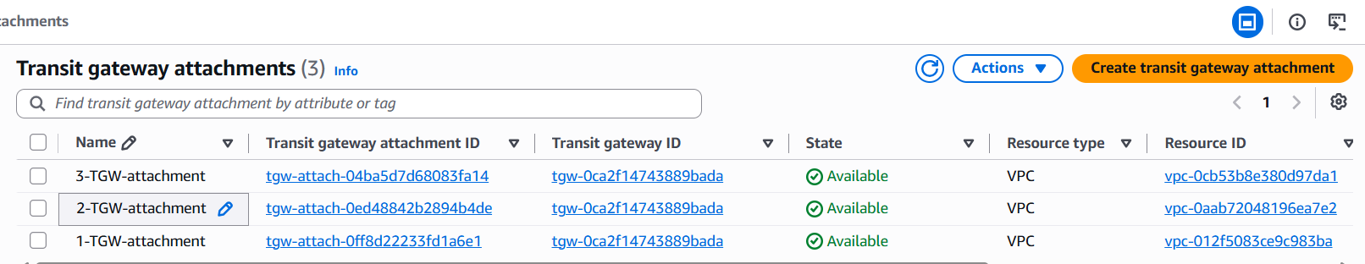
Configure the route tables with CIDR of other VPC’s which we are attaching
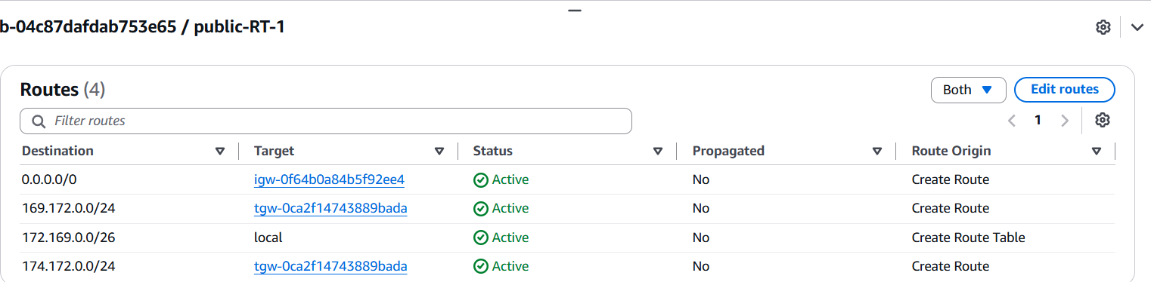
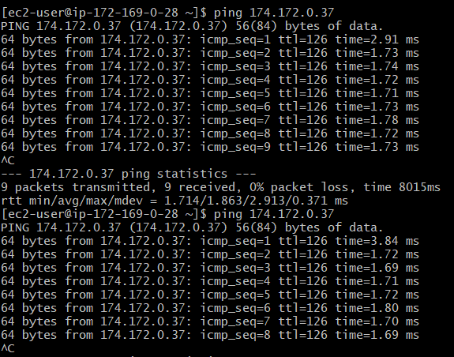
5.Set up an end point
For setting up the end point, you need to have one VPC
With 2 subnets, one is public and one is private
And then create the end point with attaching our VPC and the private subnet RT,
So the end point has been created
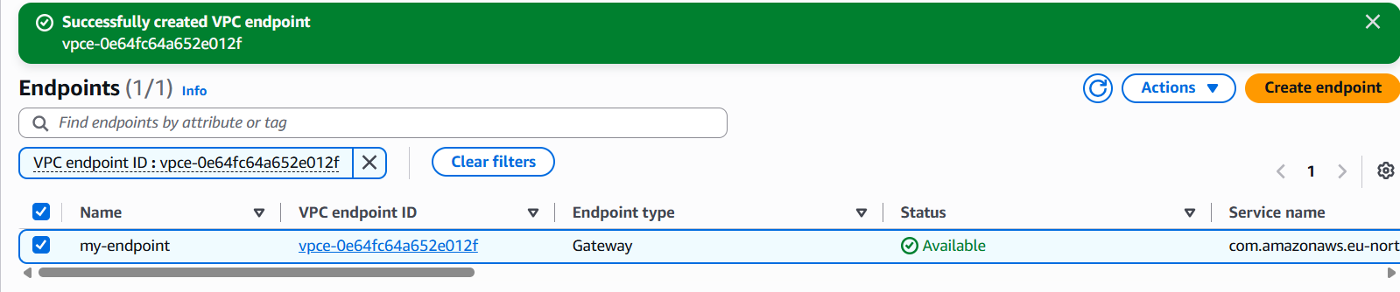
Then create 2 instance with public and private, so that we need to use the endpoint to make the private instance communicate with the other AWS services like S3
Configure the Security group by adding SSH
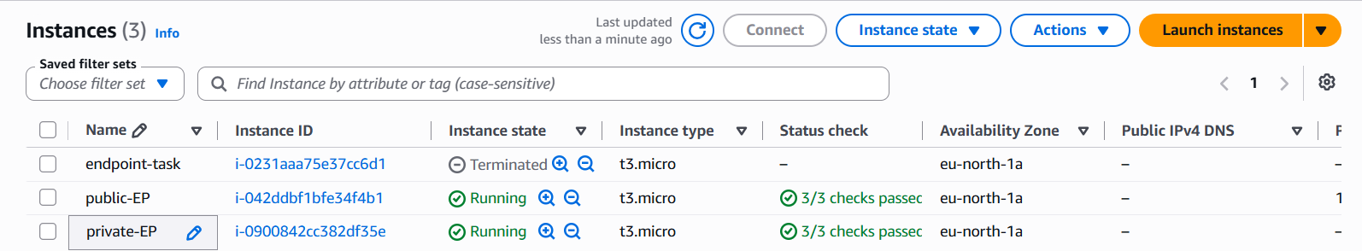
Then copy the pem key and login to public instance
Create a new file with .pem and past the key and give 400 permission(Read)
Then configure the AWS with the below steps, it connects to S3
